Mid-Term Project Assignment Report

Feet Size Measurement using Homography and Pixel Per Metric

BY

Rohit Das

National Taiwan Normal University

[61047086s@ntnu.edu.tw](mailto:61047086s@ntnu.edu.tw) , +886-905023713

**Introduction:**

This is a mid-term assignment for finding the size of feet using homography and calculate the dimension using pixel-per-metric ratio.

**Workflow:**

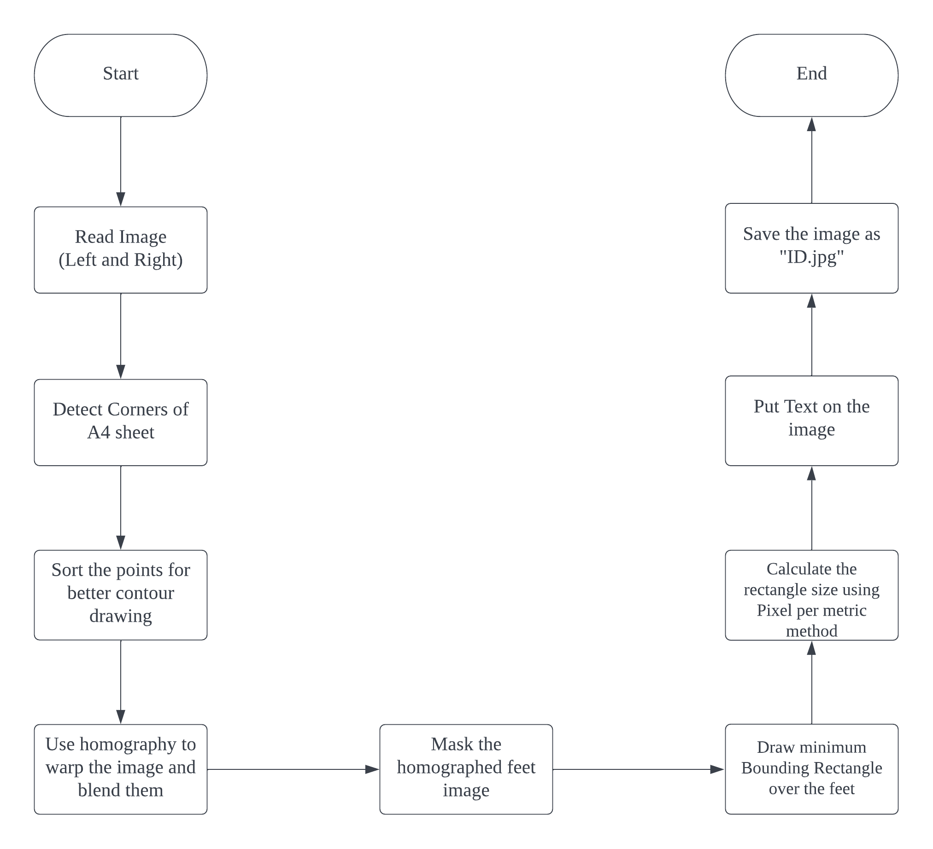

**Challenges:**

1. Environment issues: Since the floor of my room has square tiles and too much textures, it was difficult to detect the A4 sheet.

Solution: Used a black sheet as a background and put the A4 sheet above it.

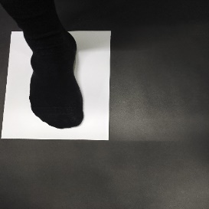 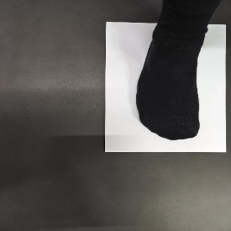

1. Blending issues: Poisson blending was my initial thought but it was not good enough.

Solution: addWeighted function of OpenCV helped me in this situation.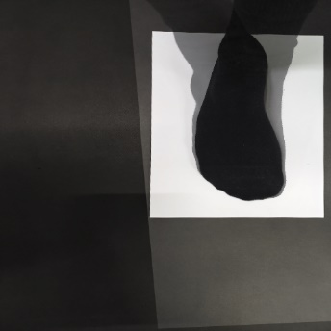

1. Feet mask from homographed Image: The above homographed image pose a big problem since the overlapping images creates a shadow which makes it difficult to remove the feet.

Solution: use Thresholding and find the threshold by trial and error. Then apply bitwise operation to get the mask.

 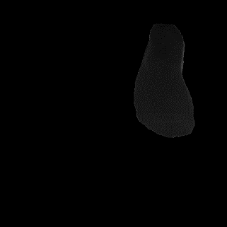

1. Size of the Feet: For this problem I created a minimum bounding rectangle over the feet. Then I used pixel per metric ratio to find the size.

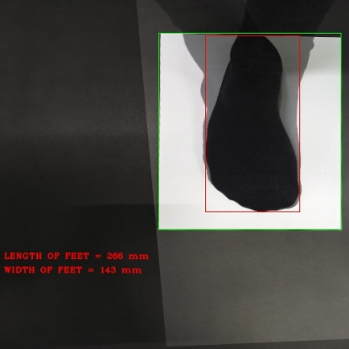

**Result:**

Length of Feet in Real World = 255 mm

Length of Feet in the image = 266 mm

Accuracy +95%

Width of Feet in Real World = 102 mm

Width of Feet in the image = 143 mm

Accuracy +70%

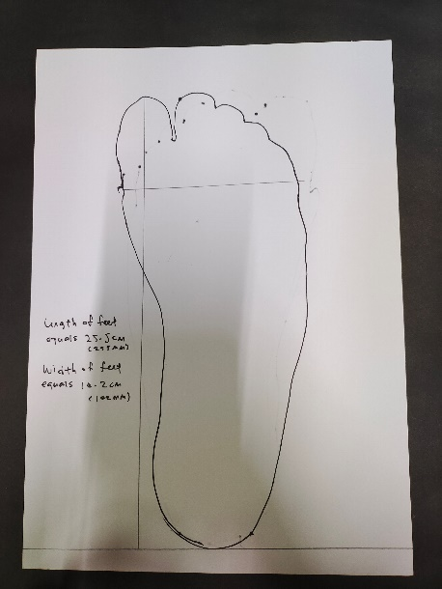 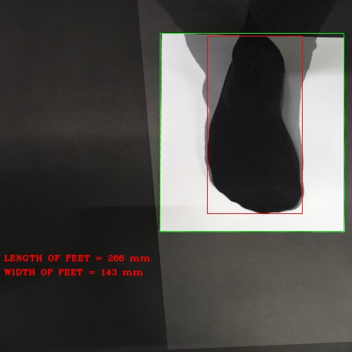

**Conclusion:**

I am satisfied with the result. Though I believe I could make the codes much simpler. The total duration for completing this project took 7 days. These kinds of problems relate more to Photogrammetry. I really enjoyed doing this assignment. I thank professor for giving us this assignment.